CIS500 Fundamentals of Computer Science

Proj 4 – Loan Management Application

Jie Tao

Dec 5th, 2017

**Read Me for Simple Loan Application**

1. **Function description**

This Simple Loan Application is used for maintaining customers and loans on the bias of two loan types. There are three basic functions: customer management, loan management and summary. See picture blew:

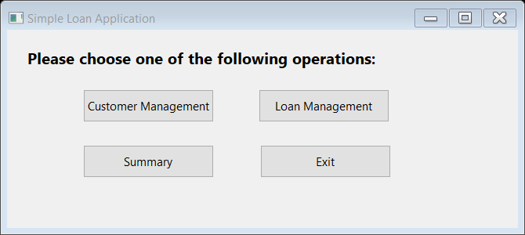

1. **Customer management is used to add/delete customer or show all customer list.**

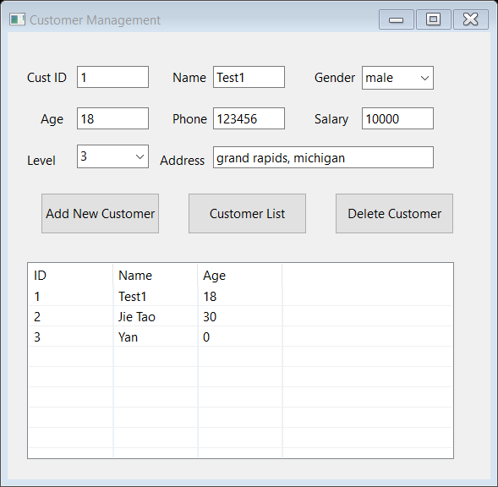

A: add a new customer into database after filling out the new customer information

B: click “customer list”, it shows all customer basic information

C: choose one customer in the customer list, you can delete it by click delete button

1. **Loan Management is used to add/edit/delete one or more loans to a customer.**

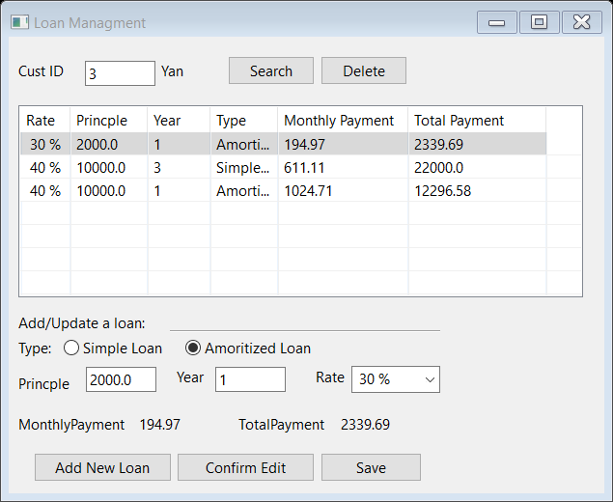

A: after entering a customer id, click search button, the table blew shows all loans under this customer. If the customer or loan is not found, there will be a message windows like blew:

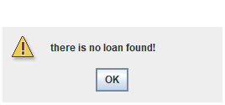

B: user can enter the loan information, and click add new loan, the application will show the monthly payment and total payment. Also, this new record will add to the loan list.

C: choose one of loan record in the list, user can edit it as same way as add new loan, after completing edit, click confirm edit to show new result on the loan list.

D: when user finishes all operations, click save button to write all data into database. [ONLY way to save data is to click SAVE button]

E: choose one of loan record in the list, user can delete the spec loan.

1. **Summary of Loans**

Summary is used to show how many loans and total amount by cusmters. And the total number of Loans and total amount of payment.

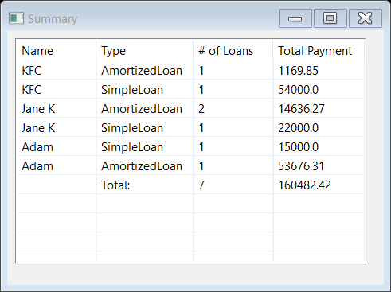

1. **Architecture description**

The program is developed by java and data is stored in access 2016 through SQL.

1. **Class diagram**

* SimpleLoan and AmoritizedLoan inherit from Class Loan, but achieve different loan calculation.
* LoanType is enum class which relates to two loan type.
* Loan Manager is used to operate loan through a loan arraylist.
* Customer is used to operate customer, since it is simple, so it is not necessary to add a customer manager class.
* DataAccess connects to database and executes SQL.

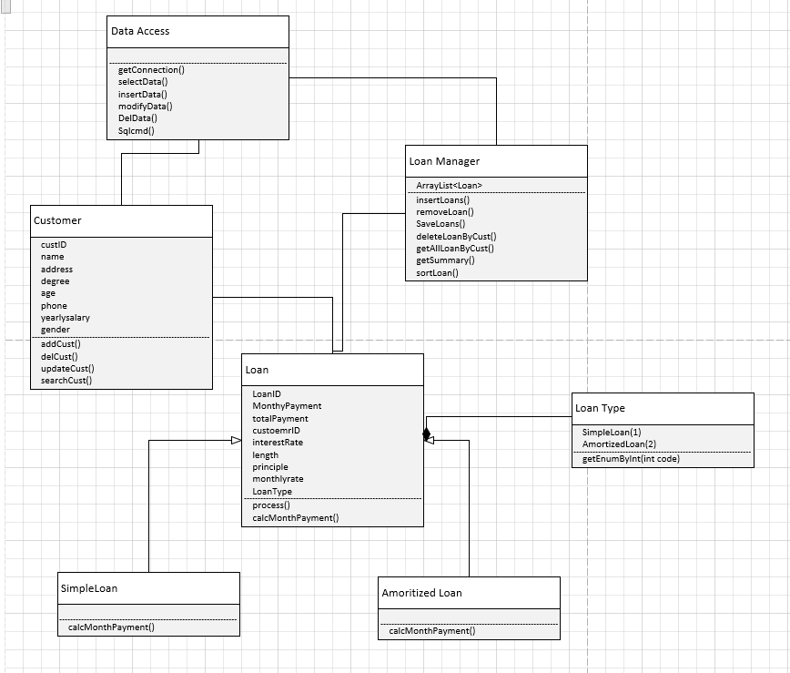

1. **Database Table**

Customer:

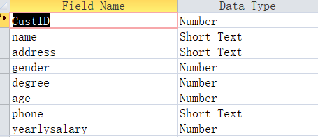

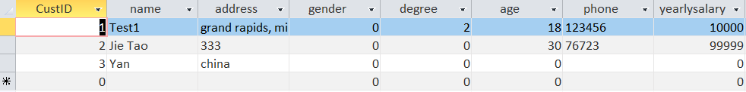

Loan:

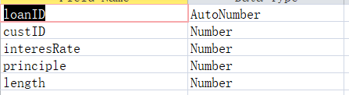

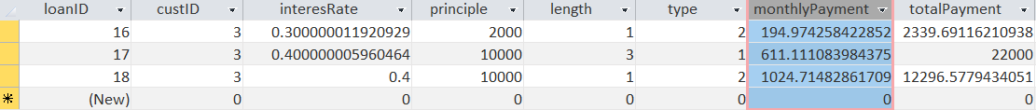

1. **HCI Layer**

There are total 4 user interfaces: RunLoan.java, fCustomer.java, fLoan.java, fSummary.java. except handling event, most of interfaces are designed by windowsbuilder.

Appendix I: Another prototype is coded by python through persistence in a text file.